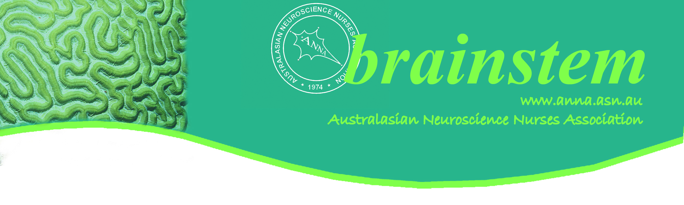
PRESIDENT’S MESSAGE
The early months of the year for most of us signal a time of increased activity professionally as we return from holidays looking at what the coming year has in store. I have a few opportunities in mind! Let’s begin with the upcoming ANNA Meeting on the Gold Coast in August – the 30th to 31st to be precise. It promises to be a great conference in a beautiful location - the Sheraton Mirage - situated on Main Beach, Gold Coast. We are once again collaborating with the Neurosurgical Society. Leigh McCarthy is convenor for the conference.
It will again provide everyone with mix of education and networking opportunities and a great social program on offer. Please check the dates listed in the flyer for deadlines for abstract submissions as well as early bird registration. If you are planning to present at the conference consider the scholarship opportunities available: the Barbara Lester Scholarship Fund and the Louie Blundell Scholarship. The details of both scholarships are available on the ANNA website and the closing date is the 31st May.
We would like to hear from you regarding the changes we made to the process for joining and renewing ANNA memberships. Because we have opted for online renewal processes please ensure you keep us informed of any changes to your email contact details. We recommend using your home email as your contact when renewing your membership.
As you may be aware the next WFNN Congress will be held in Darwin in July 2021which is very exciting. The vote for Darwin was held at the WFNN Executive Meeting in Croatia in September last year and was overwhelmingly in favour of Darwin. As an ANNA member you will be receive information about the Congress in the coming months. And it is not too early to starting thinking about abstract submission. This is an opportunity to showcase globally what you are doing as neuroscience nurses in Australia and New Zealand. By the way we are delighted to welcome back New Zealand as a chapter of ANNA thanks to the efforts of some keen local neuroscience nurses.
Within this newsletter you will find a nomination form for chapter positions including Branch Delegate and Secretary. There are vacancies for the NSW Chapter so if you are interested please submit the nomination form.
Lastly our journal is now online. Our editor, Linda Nichols, is getting together the next edition due in May. Please contact her if you have a paper you would like to submit for publication. The details for submission are on our website and there is support out there for you if this is your first time writing for publication. Having the journal online provides many benefits but most importantly it is open access which means that it is available to anyone with internet connection. That can only benefit patients as the case studies, research projects or literature reviews you publish will help to educate neuroscience nurses internationally as well as within Australia and New Zealand.
See you on the Gold Coast in August!
Jeanne
ANNA President

ANNA CONTACTS

ANNA | PO Box 193 Surrey Hills Vic 3127 Email: anna@pams.org.au  Phone: 03 9895 4461 Fax: 03 9898 0249
For specific executive inquiries, please contact the relevant committee member

President |  | Jeanne Barr | president@anna.asn.au
Vice President |  | Debbie Wilkinson | vicepresident@anna.asn.au
Treasurer |  | Catherine Hardman | treasurer@anna.asn.au
Secretary |  | Kate Lin | secretary@anna.asn.au
Webmaster |  | Sharryn Byers | webmaster@anna.asn.au
Conference Convenor |  | Leigh Arrowsmith | conferenceconvenor@anna.asn.au
Journal Editor |  | Linda Nichols | editor@anna.asn.au

Executive Committee Vacancy Notice
Dear members, the NSW state delegate position has become vacant recently. If you are passionate about Neuroscience Nursings and would like to be part of the Executive to promote ANNA with us, please apply. If you know someone would be interested, please encourage them to apply.
You can find the nomination form on ANNA website or as below.

SAVE THE DATE

Held in conjunction with the Neurosurgical Society of Australasia.

For sponsorship, exhibition and attendance information, please contact:
Website: www.neuroasm.com.au
Email: nsa.asm@surgeons.org
Phone: +61 3 9276 7431

To register, https://nsa.eventsair.com/anna2018/register/Site/Register
Or go to ANNA website for link.

READING CORNER
One of our ANNA members, Caleb Ferguson, was part of a team of researchers that recently completed a project which was funded by the Nancy & Vic Allen Stroke Prevention Fund. This project involved conducting a number of systematic reviews looking at the evidence of complementary or traditional medicine for stroke prevention. Attached two systematic reviews that we thought would be of interest to our members. Happy reading.
Both can be found through the below link:
https://www.ncbi.nlm.nih.gov/pubmed/29137055
https://www.ncbi.nlm.nih.gov/pmc/articles/PMC5584346/

